Send Instruments for Calibration

Here is how to mail instruments, such as ion chambers and survey meters, to labs (usually K&S) for periodic calibration.

1. Get the shipping boxes from the hot lab. The boxes are filled with shaped Styrofoam to conform to their contents. The boxes are labelled by the instrument they are for.
2. Print out as many copies of the PO, PR, and, if you have it, the notice of calibration due dates, as there are boxes.

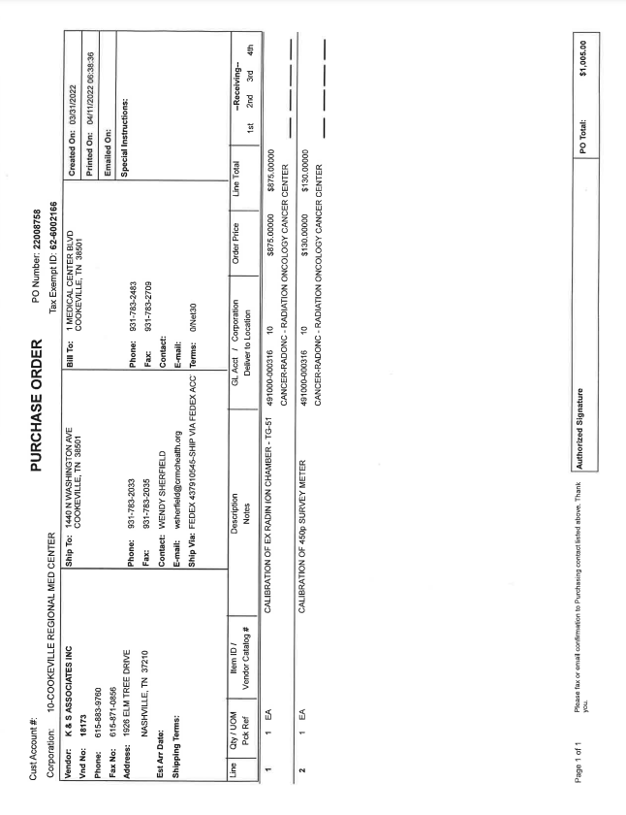

**PO**

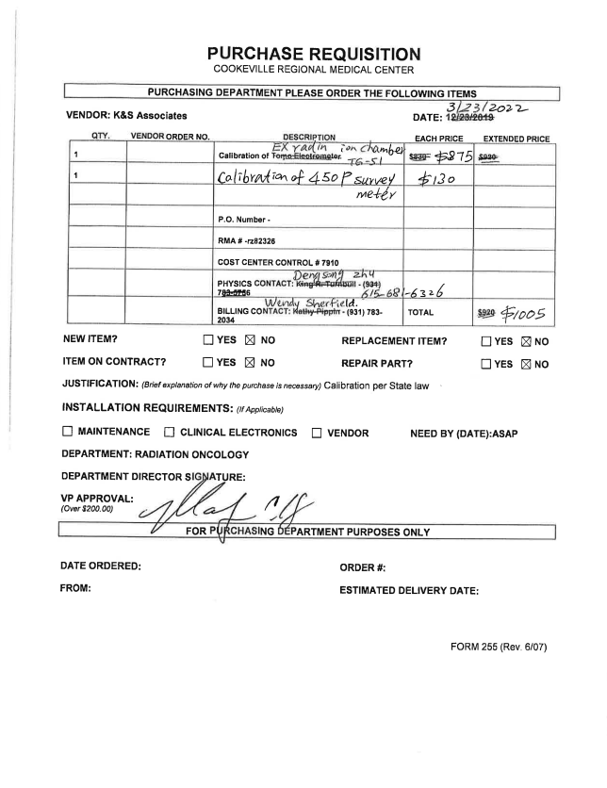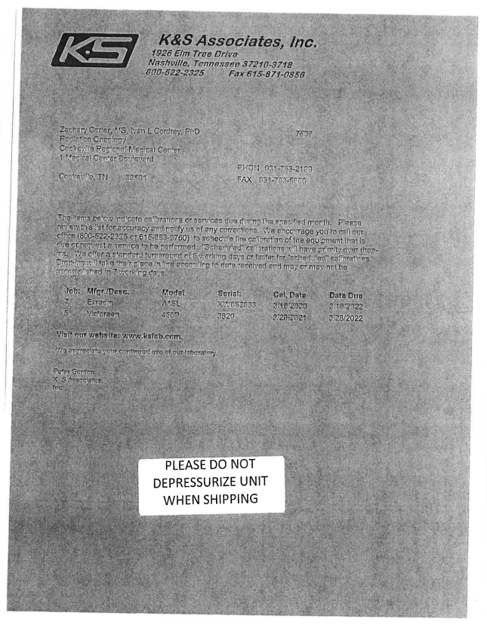

**cal notice**

**PR**

Staple together each set of papers.

1. Place each instrument in its box and cover with the Styrofoam “lid.”

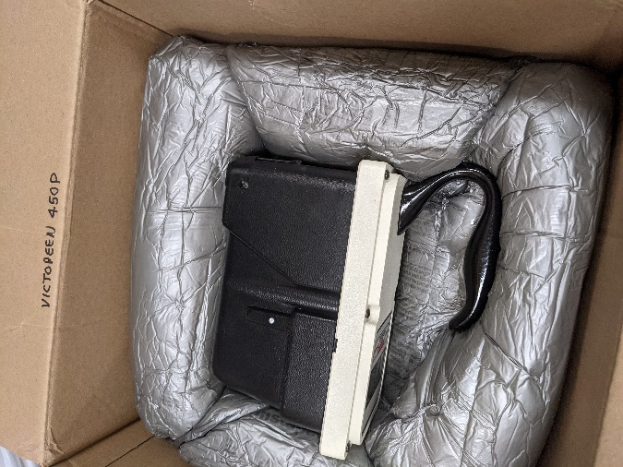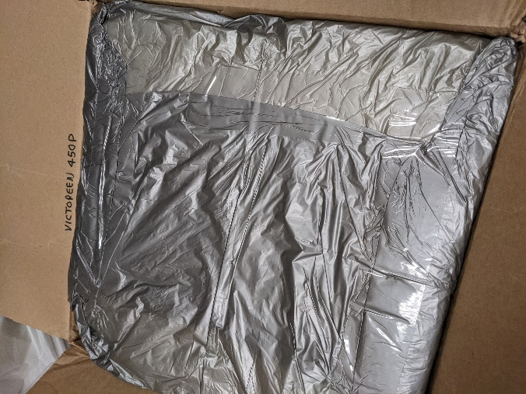

1. Add the papers to each box.

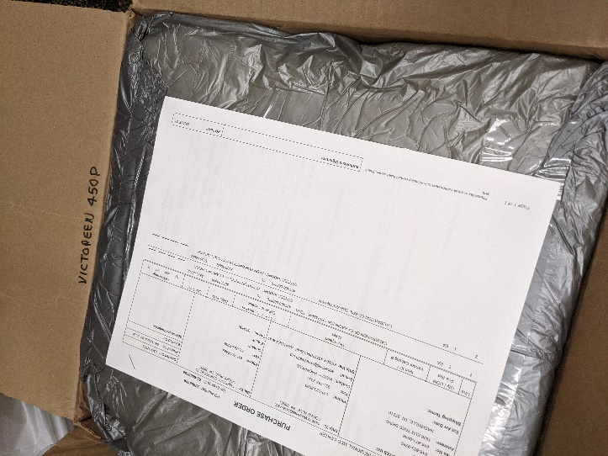

1. Seal each box with packing tape and affix a shipping label.
2. Take the boxes to the front office for the manager to mail to the lab.